|  |  |  |  |
| --- | --- | --- | --- |
| **Lyng Primary School Knowledge Organiser** | | | |
| **Topic: Egypt** | **Was the river Nile a purposeful water source?** | Year 3  Battles, beliefs and buildings | Autumn 2/Spring 1 |

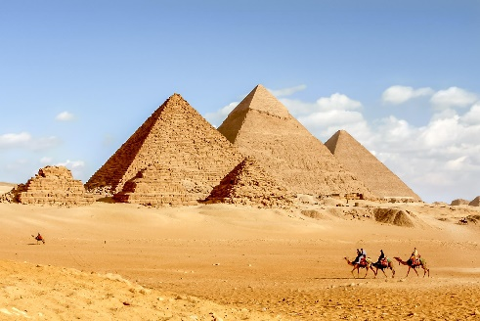

**Background information for parents and teachers**

Most of Egypt is a vast desert with almost no rainfall. The River Nile is one of the longest rivers in the world and it flows northwards from the mountains of Tanzania for over 6,000km on its way to the Mediterranean Sea. For more than 6,000 years the river has enabled people to live in Egypt.

|  |  |
| --- | --- |
| **What Step On and Goldilocks words will I use?** | |
| **Spelling** | **Definition** |
| continents | A **continent** is a very **large area of land,** such as Africa or Asia, that consists of several countries. |
| desert | A **desert** is a large area of land, usually in a **hot region**, where there is almost no water, rain, trees, or plants. |
| equator | The **equator** is an **imaginary line around the middle of the Earth** at an equal distance from the North Pole and the South Pole. |
| floodplain | The **floodplain** is the **flat area** bordering a river that gets **flooded.** |
| main channel | The **main channel** is the **widest part** of the river. |
| meander | If a **river or road meanders, it has a lot of bends**, rather than going in a straight line from one place to another. |
| mouth | The **mouth** of a river is the place where it **flows into the sea**. |
| source | The **source** of a river is the **original point** where the river **starts from.** |
| tropics | The **tropics** are the **parts of the world that lie between two lines of latitude**, the Tropic of Cancer, 23½° north of the equator, and the Tropic of Capricorn, 23½° south of the equator. |
| waterfall | A **waterfall** is where water **falls over a high cliff** into a pool. |

|  |
| --- |
| **Geographical study** |
| * Name and locate the Equator, Northern Hemisphere, Southern Hemisphere, the Tropics of Cancer and Capricorn, Arctic and Antarctic Circle and date time zones. Describe some of the characteristics of these geographical areas. * Describe key aspects of: **physical geography**, including: rivers * Human geography, including: settlements and land use. |

**Fieldwork Opportunities**

River fieldwork

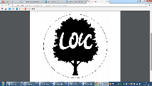

**Significant places**

* Egypt
* The Nile

**Our Storytelling Approach to enhance engagement**

|  |  |  |
| --- | --- | --- |
| **People:**  Egyptologists | **Place:**  Valley of the Kings, Egypt | **Problem:**  An unknown tomb |

**Key facts and locations**

**Diagram to be studied**

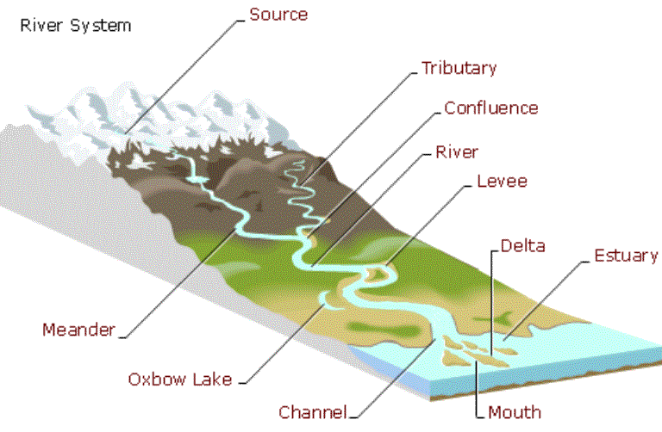

The River Nile is about 6,670 km (4,160 miles) in length and is the longest river in Africa and in the world. Although it is generally associated with Egypt, only 22% of the Nile’s course runs through Egypt.

In Egypt, the River Nile creates a fertile green valley across the desert. It was by the banks of the river that one of the oldest civilizations in the world began. The ancient Egyptians lived and farmed along the Nile, using the soil to produce food for themselves and their animals.

Most Egyptians lived near the Nile as it provided water, food, transportation and excellent soil for growing food.

Ancient Egypt could not have existed without the river Nile. Since rainfall is almost non-existent in Egypt, the floods provided the only source of moisture to sustain crops.

Every year, heavy summer rain in the Ethiopian highlands, sent a torrent of water that overflowed the banks of the Nile. When the floods went down it left thick rich mud (black silt) which was excellent soil to plant seeds in after it had been ploughed.

The ancient Egyptians could grow crops only in the mud left behind when the Nile flooded. So they all had fields all along the River Nile.

**Enquiry Questions:**

How is the Earth divided on a map and a globe?

How is a river formed?

Where can we find rivers?

How did Ancient Egyptians use the river Nile?

What can we find out about local rivers?

How can we study our local river? (fieldwork).

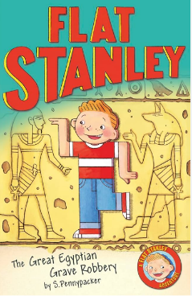

**Agreed Outcome**

A 3D collage of a river labelled with features

|  |  |  |  |
| --- | --- | --- | --- |
| **Lyng Primary School Knowledge Organiser** | | | |
| **Topic:** | **Life on the Nile**  **(How was the Nile used?)** | Year 3  Battles, beliefs and buildings | Autumn 2 |

|  |  |  |
| --- | --- | --- |
| What is a meander? | **S** | **E** |
| A straight part of a river |  |  |
| A bend in a river |  |  |
| A type of water |  |  |

|  |  |  |
| --- | --- | --- |
| Which sea does the Nile flow into? | **S** | **E** |
| The Atlantic |  |  |
| English Channel |  |  |
| Mediterranean Sea |  |  |

|  |
| --- |
| Name the capital city of Egypt. |
| S = E = |

|  |  |  |
| --- | --- | --- |
| The Egyptians tried to stop the flooding of the Nile. | **S** | **E** |
|  | True  False | True  False |

|  |  |  |
| --- | --- | --- |
| Where was Ancient Egypt located? | **S** | **E** |
| North Africa |  |  |
| Australia |  |  |
| South America |  |  |

**Egyptian Geography Quiz**

|  |  |  |
| --- | --- | --- |
| The Nile is… | **S** | **E** |
| The longest river in the World. |  |  |
| The shortest river in the World |  |  |
| The 2nd longest river in the World |  |  |

**Start :**

**End :**

|  |  |  |
| --- | --- | --- |
| Where does a river start? | **S** | **E** |
| Cairo |  |  |
| source |  |  |
| ice |  |  |

|  |
| --- |
| Name a continent of the World. |
| S = E = |

|  |  |  |
| --- | --- | --- |
| What can you use a compass for? | **S** | **E** |
| Travelling. |  |  |
| Painting. |  |  |
| Cairo. |  |  |